**Progress Report for the Week of August 17th**

Finally, Made the API for the website using the Django REST framework module and updated the graphs with the JSON data from the Database using javascript and Chart.js bootstrap. The api is shown below for the Power Table.

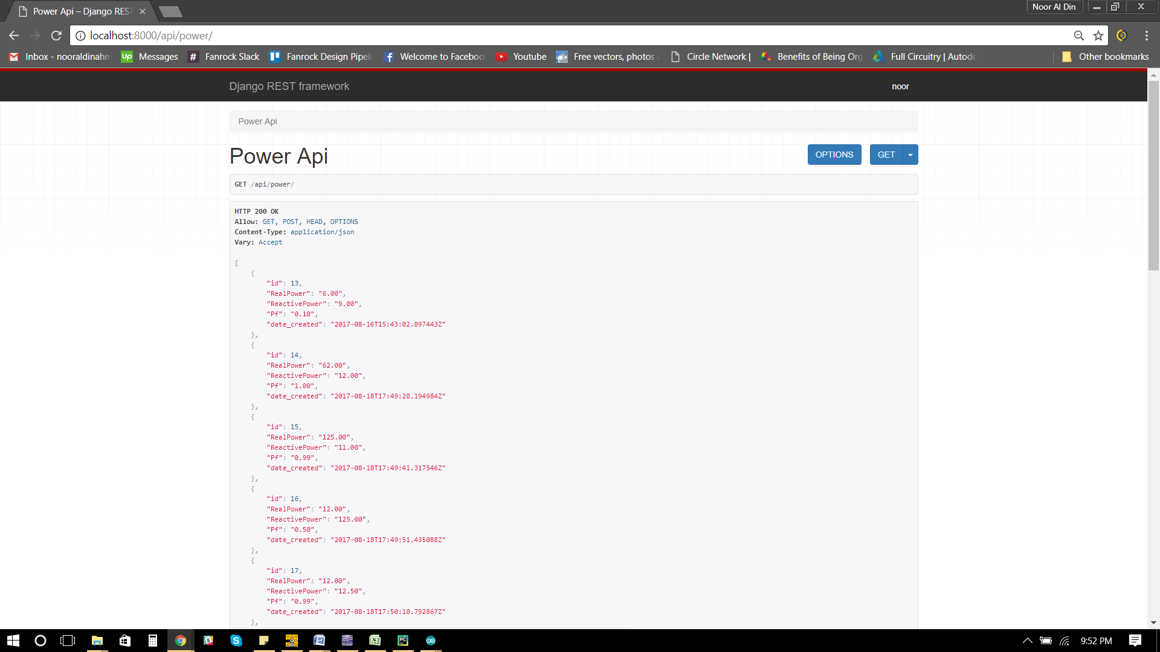

Made the Zero Crossing detector circuit on a veroboard. Tested it, and it ran as expected, similar to previous results.

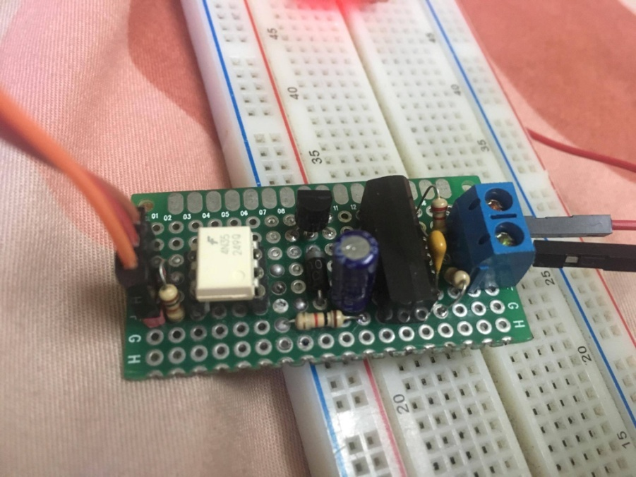

Calculated the standard deviation, variance and mean error value using 9 sample values. as asked as shown below.

|  |  |  |  |  |  |
| --- | --- | --- | --- | --- | --- |
| I | T(ms) | T(s) | Mean | Ti-T(mean) | (Ti-T(mean))^2 |
| 1 | 650 | 0.00065 | 0.000661 | -1.11111E-05 | 1.23457E-10 |
| 2 | 700 | 0.0007 | 0.000661 | 3.88889E-05 | 1.51235E-09 |
| 3 | 600 | 0.0006 | 0.000661 | -6.11111E-05 | 3.73457E-09 |
| 4 | 650 | 0.00065 | 0.000661 | -1.11111E-05 | 1.23457E-10 |
| 5 | 700 | 0.0007 | 0.000661 | 3.88889E-05 | 1.51235E-09 |
| 6 | 700 | 0.0007 | 0.000661 | 3.88889E-05 | 1.51235E-09 |
| 7 | 650 | 0.00065 | 0.000661 | -1.11111E-05 | 1.23457E-10 |
| 8 | 600 | 0.0006 | 0.000661 | -6.11111E-05 | 3.73457E-09 |
| 9 | 700 | 0.0007 | 0.000661 | 3.88889E-05 | 1.51235E-09 |
| SUM | 5950 | 0.00595 |  | 6.50521E-19 | 1.38889E-08 |
|  |  |  |  |  |  |
|  | Mean = |  | 0.000661 |  |  |
|  | Variance= |  | 1.74E-09 |  |  |
|  | Standard Deviation= | | 4.17E-05 |  |  |

The values were manually logged in using the pictures shown below that was taken from the Lab’s digital oscilloscope.

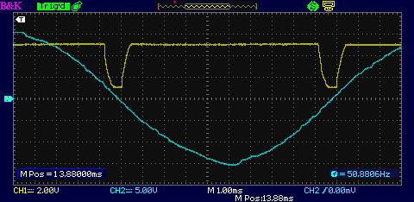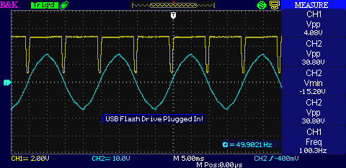

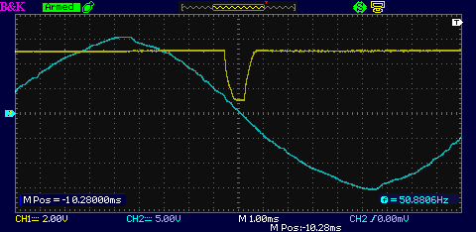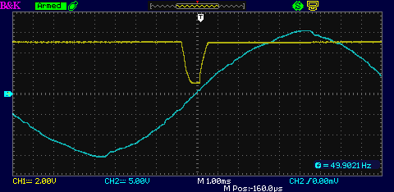

These are just a few pictures posted out of many.